Constitution and Citizenship Day and Banned Books Week

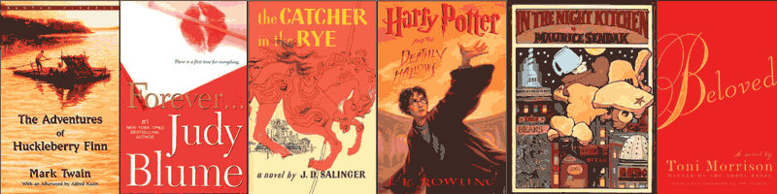

Burn the Books:

The Fight for Free Expression

Tues., Sept. 23, 2014, 7 p.m., 1310 & 1311, Learning Commons, Perry Library

Presented by

Old Dominion University, the College of Arts and Letters, & the University Libraries Reception at 6:30 p.m. in front of the Learning Commons

"Censorship is telling a man he can't have a steak just because a baby can't chew it."

– Mark Twain

Hundreds of books are challenged in public schools and libraries each year.

Who can challenge a book? How does a book’s popularity affect challenges? Where does intellectual freedom end and censorship begin? What does the First Amendment’s free expression clause really mean?

Keynote Speaker:

Alicia Defonzo, Instructor, English Department

Panel Discussion:

Associate Professor KaaVonia Hinton- Johnson, Department of Teaching and Learning in Education; Assistant Professor Elizabeth Groeneveld, Department of Women’s Studies; Assistant Professor Shenita Brazelton, Department of Political Science and Geography, and Ms. Lucinda Rush, Education Reference Services Librarian.

Moderator:

Elizabeth Esinhart, Director, Interdisciplinary Studies

