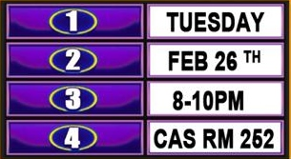

DON’T HATE THE PLAYER, HATE THE GAME

**UNIVERSITY VILLAGE SOUTH**

**AND**

**MPOWER PEER EDUCATION NETWORK**

PRESENT:

**NEWPORT NEWS ROOM**

**7:30 PM**

**APRIL 24TH**

**THURSDAY**

**THE GAME OF SEX**