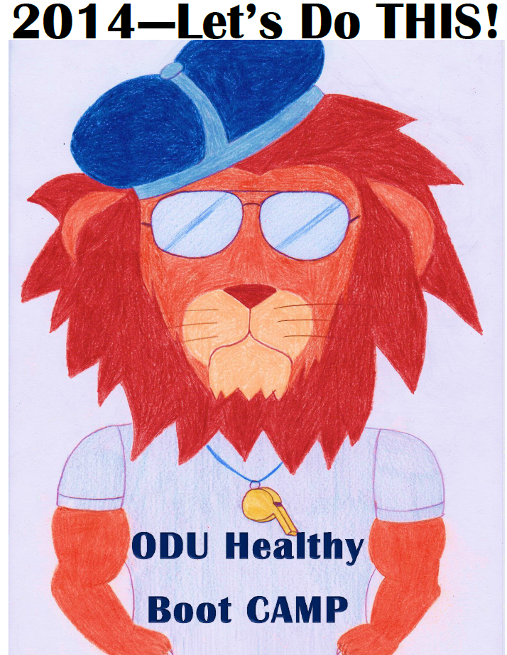

If you’re like most of us, your New Year’s resolution may be to get healthier this year. This is an invitation to participate in innovative research that may potentially increase your success with health behavior goals! If you would like to be part of the ODU Healthy Boot CAMP, a completely online study, please contact me at gdlim001@odu.edu for more study information. Alternatively, you may directly complete the 10-15 minute pre-screen survey at: https://odu.co1.qualtrics.com/SE/?SID=SV_9HNPkqpYz8Eh7Ct. Completion of the pre-screen survey will enter you into a $25 raffle. If you’re eligible, you will be invited to participate further in the study and your participation will enter you into raffles for cash prizes and the chance to win a Nexus 7 tablet!

Sincerely,
Gabby D’Lima, M.S.
Applied Experimental Psychology

