- Access LEO-Online
http://www.leoonline.odu.edu

- Click on Enter LEO Online News and Secure Area then click Enter Secure Area

- Log in using your Midas ID and Password

- From the Main Menu click Employee then click Employee Self Service to open the Employee Dashboard

- From the Employee Dashboard click on Direct Deposit Information as highlighted in yellow below

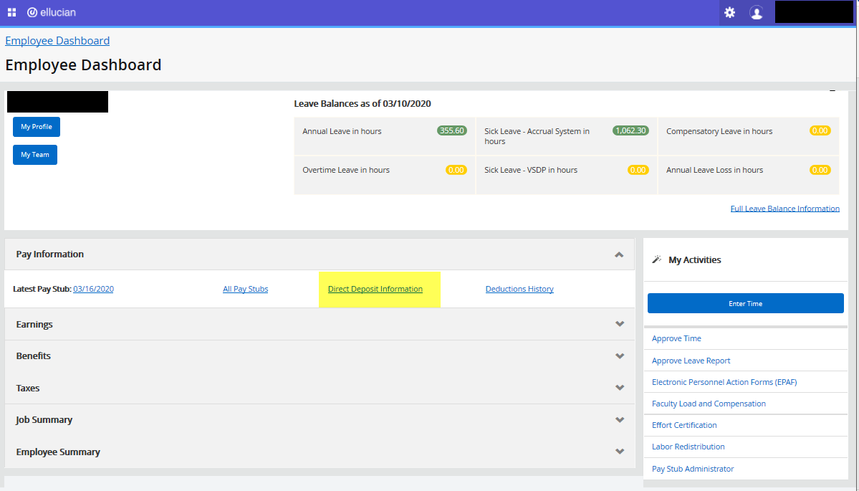

- At the top of the page you will see your current Direct Deposit Allocations as of your last pay date.

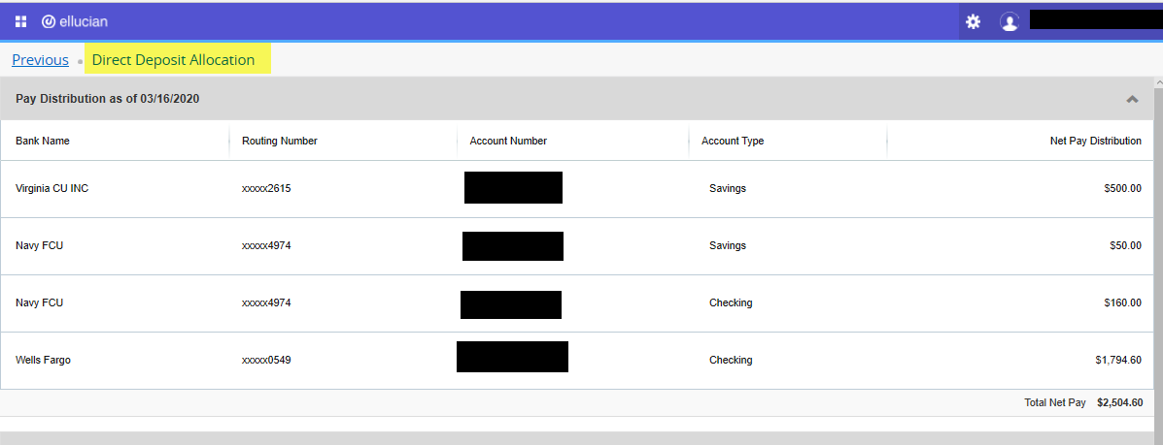

- The next section titled “Proposed Pay Distribution” is where you will make changes to your Direct Deposit Information
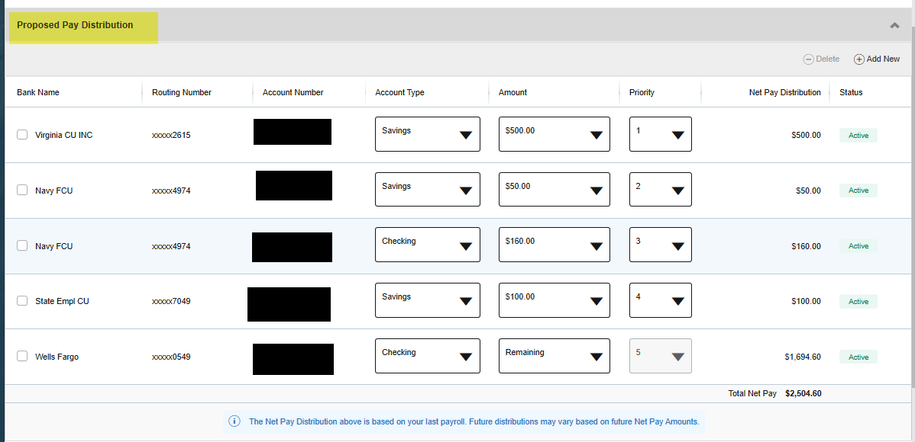

- To delete an exsisting account click the box under Bank Name beside the account you would like to delete. The box will turn blue and you will see a check mark in the box then click delete. You will receive the notice are you sure you want to delete…. Click delete and the item is removed from the list. If you have multiple accounts the amount for the account deleted will be added to your net pay direct deposit line.
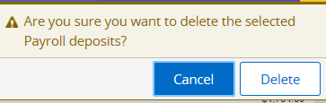
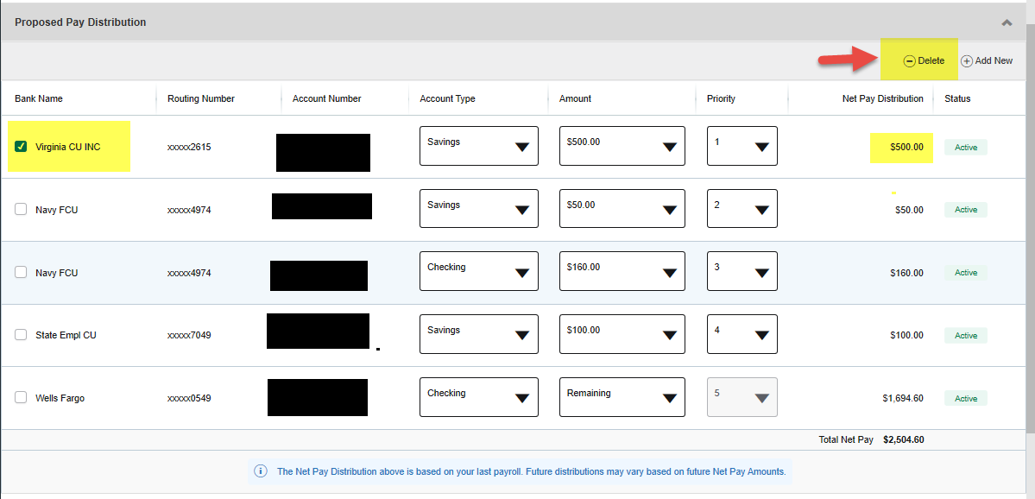

- To add a new account, click “Add New” from the “Proposed Pay Distribution” section a pop-up box will appear title “Add Pay Allocation” – create new. You will be prompted to key the new bank routing number, account number and account type in the pop up box (Please make sure this information is correct) then you will choose the amount from the options listed in the pop up box – you will also check the box authorizing payroll to credit or debit your account – select “save new deposit”
Note: the “Create from existing account” option should only be used when setting up your Accounts Payable direct deposit using one of your payroll accounts
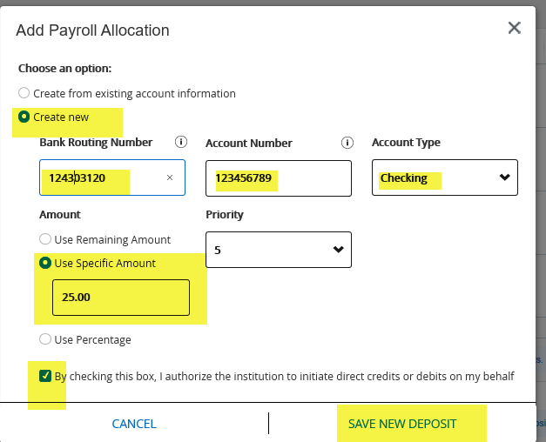

The new bank information will appear under “Proposed Pay Distribution”
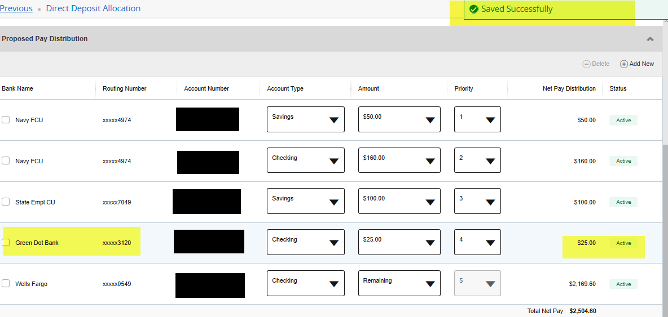
Making Changes to an Existing Account
To make changes to an existing account select the account you wish to change from the “Proposed Pay Distribution” section. You may change the account type, amount, or priority.
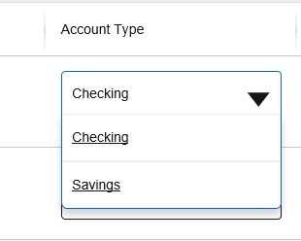
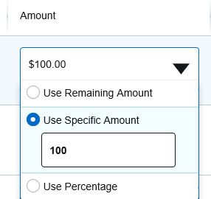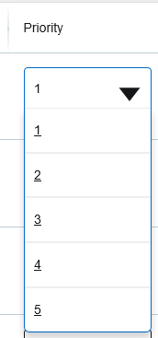

Notes: The payroll amount is designated as Remaining, Specific or Percentage. Use Specific Amount to deposit a designated dollar amount into an account then select the priority. Use the Percentage to designate a percentage of your pay to a specific account the select the priority. Remaining is used to deposit the amount of your paycheck after all prior allocations are deposited into the designated accounts. You will not have the option to select a priority for “Remaining” because it will always occur last. Check the Disclaimer check box and click “Save New Deposit”.

Setting Up your Accounts Payable Deposit
Employees can set up banking direct deposit information for their Accounts Payable transactions by completing the Accounts Payable Deposit Section.
Employees can select “Create from existing...” to set up their Accounts Payable Direct Deposit using one of their Payroll Direct Deposit Accounts or they can select “Create New” to add a new account.

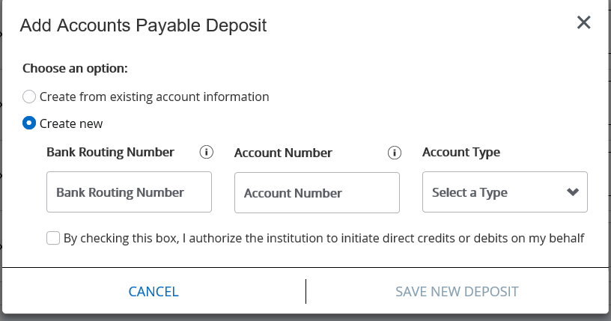

To add an Accounts Payable Deposit using ‘Create from existing…” select the payroll account you wish to use from the drop-down menu and click save.
To add a new account, select “Create New” and follow the same instructions outlined earlier for creating a new Payroll Direct deposit.
Note: Employees can have only one Accounts Payable Direct Deposit Account.
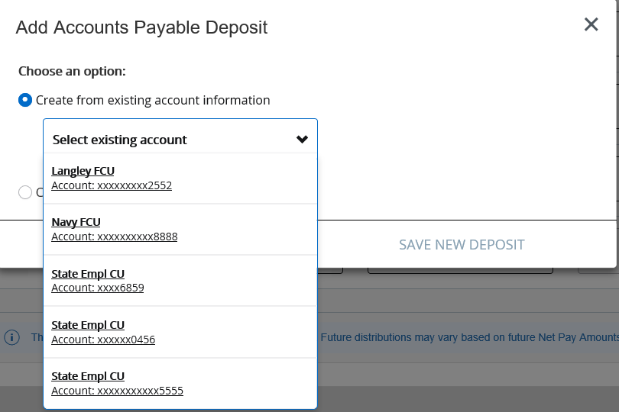

For questions contact Payroll at (757)-683-5266 or (757) 683-4337.

