 Faculty, Staff and Student 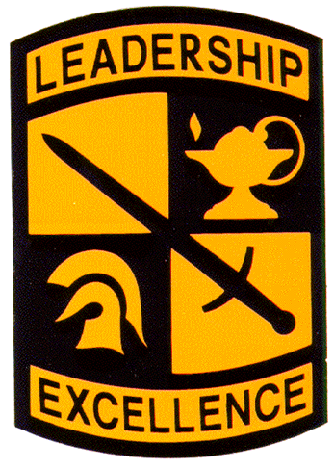

Army ROTC Rappelling

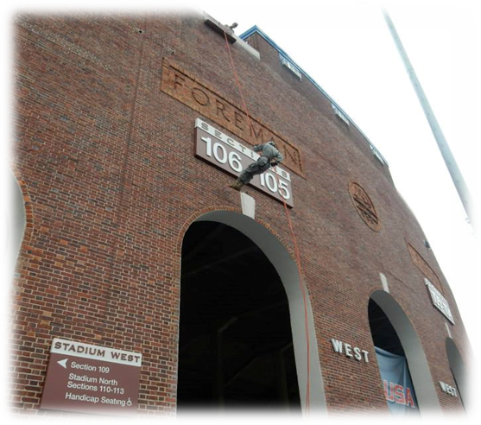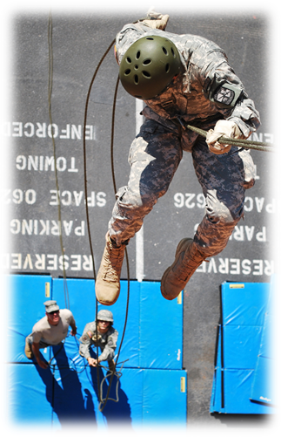
Come out and join the Monarch Battalion
rappel off the football stadium.
We will meet in front of the S.B. Ballard Stadium on April 21st at 9a.m. to 12:00p.m. to rappel down the side of the football stadium.

If you want to attend this event, please
RSVP by April 20th to: ArmyROTC@odu.edu

Questions? Call 683-3663 and ask for CPT Dyer
Join us April 21st at 9a.m. to 12:00p.m.
at S.B. Ballard Stadium!

