RED WATCH BAND TRAINING
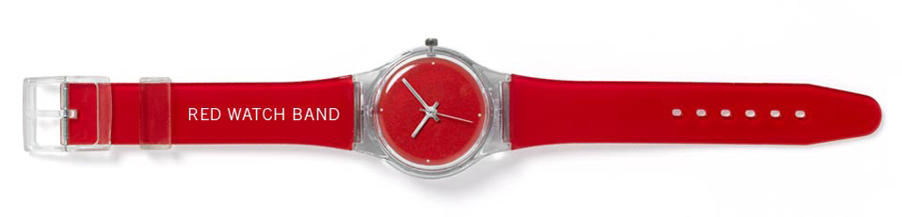
The Red Watch Band Program was designed to provide students of the college community with the knowledge, awareness, and skills to prevent toxic drinking deaths and to promote a student culture of kindness, responsibility, compassion and respect.
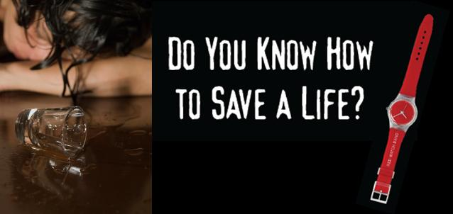
The training consists of active engagement with fellow participants and trainers that includes group discussions and role plays. There is also a health component where you will learn the core skills of CPR (hands-on only).
Show your Monarch Pride and
earn your Red Watch Band today!!!

Thursday, May 29, 2014 2:00pm – 4:00pm – Chesapeake Room
Refreshments will be provided!
Contact the Office of Counseling Services or e-mail Angela Holley at amholley@odu.edu to sign up. Maximum of 22 participants
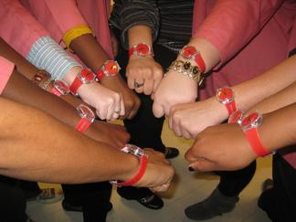
A Monarch Wellness: Physical event sponsored by the Office of Counseling Services, 757-683-4401

