Innovative Theatre - Interactive Science
For Children and Families
www.sciencealliancelive.org

Presents:
Tuk in the Arctic

Children from 4-10 will help Canadian Inuit Working Dog, Tuk, protect Dr. Victoria Hill’s chocolate supply while collecting data about sea ice and learning to be scientists.

School Shows Also Available
Goode Theatre on the ODU Campus
June 5-June 21
www.sciencealliancelive.org; 757-683-3391

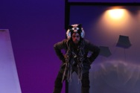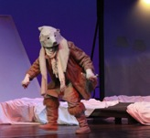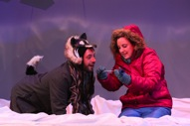

Reserve Tour Dates for 2015 Now!

The Real Dr. Hill is in the Arctic

Follow her journey on Twitter @hillinthearctic
Follow Tuk on Twitter @TukintheArctic

Like us on Facebook: https://www.facebook.com/ScienceAllianceLive

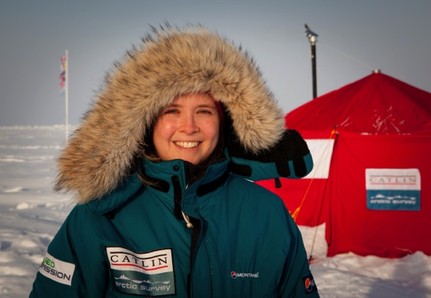

www.sciencealliancelive.org

