Frank Reidy Research Center for Bioelectrics Seminar

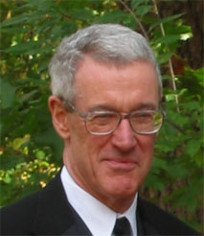
Towards Modeling of Everything for Bioelectrics

James C. Weaver, Ph.D.
Senior Research Scientist
Associate Director, Biomedical Engineering Center
Harvard-MIT Division of Health Sciences and Technology
Massachusetts Institute of Technology
Cambridge, MA 02139 USA

Tuesday, April 29
9:00 – 10:00 AM
IRP2 First Floor Conference Room
4211 Monarch Way

Living comfortably with electricity is important to humanity. It is the “smartest” known form of energy and leads to both purposeful and unintentional human exposures. For this reason we seek to understand electrical interactions with biology at all levels that might cause effects. To this end we describe a quantitative modeling approach that appears applicable on spatial scales from sub-nanometer to meters, temporal scales from nanoseconds to seconds or longer, and a wide range of electric field strengths. The approach is based on transport and other non-equilibrium processes. Modeling of electroporation is the present focus, emphasizing simultaneous electrical behavior, poration behavior and solute transport within bulk media and through dynamic pore populations.

