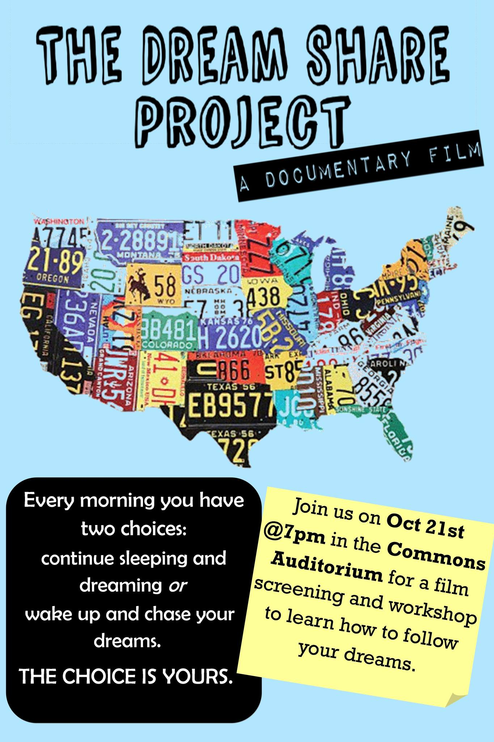

**2nd Annual Student Symposium**

**by ODU Career Management Center**

April 26, 2014 Saturday

Constant Hall 1002 from 12-3 PM

Featuring: Dream Share Project Film & Workshop

“Dress for Success” by Nordstrom

Social Media: Branding Yourself by Matt Paddock

Raffle Prizes and Pizza are provided.

Reserve your seat through ODU Careerlink. Questions? Emailbyi@odu.edu