**Heaven Bound International Campus Ministry Presents**

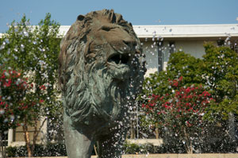

**2014 Prayer Vigil**

**When: April 26Th 2014**

**Time: 12:00pm**

**Location: Kaufman Mall**

**Free food, drinks, worship, and prayer !**