News Release: March 1, 2014 (for immediate use)
Old Dominion University Libraries
Soup to Nuts: A Musical Potluck
ODU Music Students Perform
F. Ludwig Diehn Composers Room
Thursday, March 20
12:30 to 1:15 pm

ODU’s Music Department students will cook up some fun for the 10th Annual Student Concert,
“Soup to Nuts: A Musical Potluck,” to be held from 12:30 to 1:15 pm on Thursday, March 20th at the F. Ludwig Diehn Composers Room of the Old Dominion University Libraries.

The concert, organized by Dr. Brian Nedvin, features late 20th century and contemporary music.

The F. Ludwig Diehn Composers Room is located in the F. Ludwig Diehn Fine & Performing Arts Building at 49th & Elkhorn Avenue in Norfolk —on Old Dominion University’s main Campus. The event is free and open to the public. Seating is limited. Light refreshments will be offered after the concert.

(File Photos)
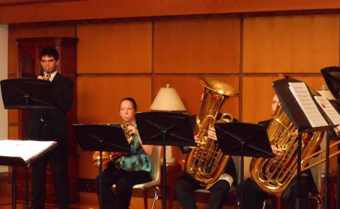
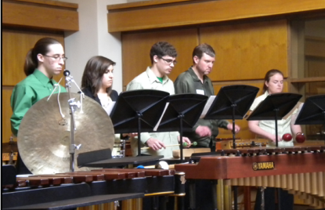

Contacts:
Elizabeth M. Hogue, Instruction and Music Collections Librarian 683-4131 ehogue@odu.edu

Jessica Mirasol, Librarian Archivist for Music Collections, F. Ludwig Diehn Composers Room
683-4175 jmirasol@gmail.com

