C:\Users\kpim\AppData\Local\Microsoft\Windows\Temporary Internet Files\Content.IE5\U7SYB2WG\MC900384030[1].wmf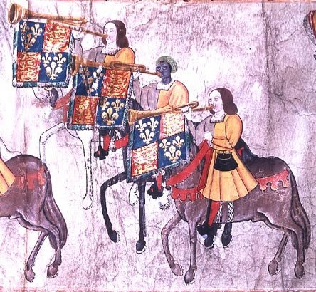

The College of Arts & Letters

Invites You to Attend the

Spring 2014 Senior Scholar Lecture

IMTIAZ HABIB  
Professor of English

***Black Studies in   
Early Modern England***

Wednesday, March 19

3:30 Reception - 4:00 Lecture

BAL 9024 (Burgess Room)

For more information, contact the Dean’s Office at 683-3925