**­

EATING DISORDERS:

2014 & BEYOND

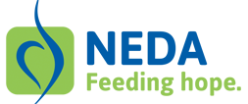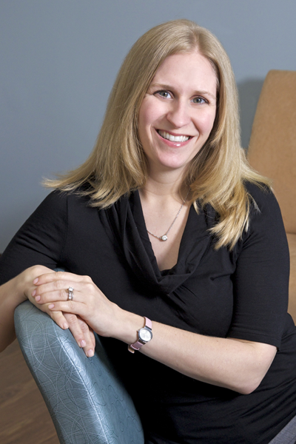

EVENT FEE:

There is no admission charge; however donations will be accepted by Chi Sigma Iota – Omega Delta Chapter and Reflections Treatment Center to present to the National Eating Disorders Association (NEDA).

http://www.nationaleatingdisorders.org/

Gary Litovitz, M.D., CEDS

Medical Director

Felicia Kolodner, LPC, NCC, CEDS

Director

CHI SIGMA IOTA – OMEGA DELTA CHAPTER WELCOMES…

Gary Litovitz, M.D., CEDS

-and-

Felicia Koldner, LPC, NCC, CEDS

…from Reflections Treatment Center at Dominion Hospital located in Falls Church, Virginia.

**EVENT DETAILS:**

*DATE*: Friday, January 24th

*TIME*: 11:00 – 12:30

*LOCATION*: River Room, Webb Center

Old Dominion University – Norfolk, VA

CONTINUING EDUCATION

This event is approved for 1.5 CEUS.

**RSVP:**

To RSVP, please go to the link below.

*https://www.surveymonkey.com/s/FSJ9YSG*

Lunch will be provided so please

RSVP so we can order appropriately.