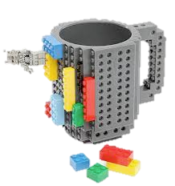

**HACE**

**Fall Social**

Wednesday,

September 11, 2013

10:00 am-12:00pm

Chesapeake Room,

Webb Center



Contact [hace@odu.edu](mailto:hace@odu.edu) for more information.

Join HACE for our annual fall social to kick off the new academic year!

Bring your own mug of coffee and we will have a contest for the MOST unique coffee mug we spot!!

We will be drawing the raffle winner for the 2013 ODU Monarch Football Season Tickets!

New Parking Director, Mr. Scott Silsdorf, will be our guest of honor to pull the lucky ticket and help judge the most unique coffee mug!