

**September 11 – Strength Circuit Class and Student Health 101 info**

**October 9 – Total Body Conditioning and Breast Cancer Awareness info**

**November 13 – Cardio Circuit Class and Healthy Holiday Eating info**

**December 4 – Power Hour and How to make a Healthy Holiday**

**New Year’s Resolution info**

**All activities are FREE**

**for students, staff and faculty**

**Sign-up in advance in the Learning Commons**

**1881 University Drive**

**Virginia Beach, VA 23453**

**757-368-4100**

**www.odu.edu/vbhec**

**FREE blood pressure screeningwill be available in the Atrium prior to the workout sessions**

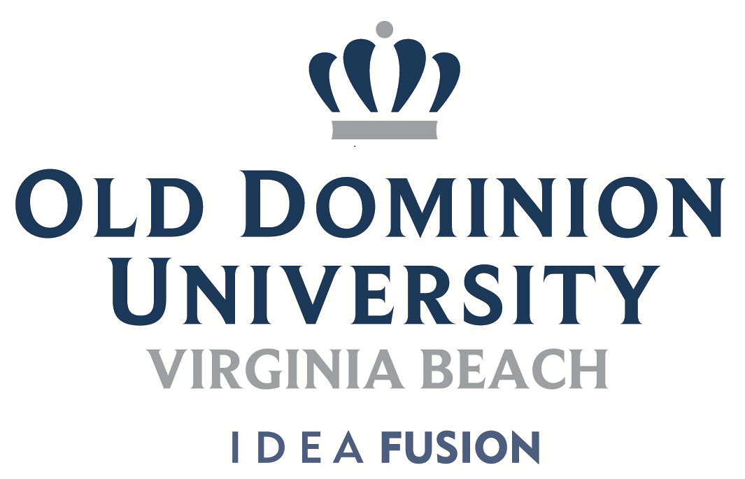

**ODU WELLNESS WAVE**

**Virginia Beach**

**Wednesdays**

**4:00 – 5:00 pm**

**Room 221**

