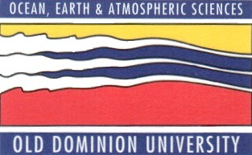

SPRING 2013 SEMINAR SERIES
DEPARTMENT OF OCEAN, EARTH, AND ATMOSPHERIC SCIENCES
3PM – ROOM 200 IN THE OCEANOGRAPHY/PHYSICS BUILDING
THURSDAY APRIL 11th, 2013

“Biodiversity, Climate Change and Human Exploitation
in the Deep Ocean”

Dr. Lisa Levin
Scripps Institution of Oceanography

ABSTRACT

Over the past 50 years our view of the deep sea has changed dramatically. Once considered homogenous and monotonous, we now recognize that the deep sea holds tremendous habitat heterogeneity from a wealth of topographic, hydrographic, geochemical and biological sources. This heterogeneity represents a major source of biodiversity, which is key to effective functioning of deep-sea ecosystems. The discovery of novel assemblages and ecosystems in recent decades has been accompanied by an expanded human presence in the form of fisheries, energy extraction, bioprospecting and minerals mining. In many cases the destructive consequences of these activities may outpace our rate of exploration and knowledge acquisition. Simultaneously, climate-change induced warming, acidification and deoxygenation are also likely to alter the ability of deep-sea ecosystems to provide key services and recover from disturbance. This talk will discuss the challenges and choices needed to maintain the integrity of deep-sea biodiversity and its functions.

After the seminar, please join us in room 404, the Zaneveld Conference Room, for coffee and cookies, and to meet with the seminar speaker.

