ODU Beach Walk Challenge

How far can you go?
Join us the whole month of April

Get ready for summer and get moving. This challenge encourages students to ‘walk along the east coast’ to a beach of your choice, as many miles as you can walk in April. Students can walk at any time on your own, or join in one of our group walking sessions. Keep track of your miles and find which beach you end up.
Start at Virginia Beach
What beach will you make it to next?

Outerbanks
Ocean City, MD
Oceanview
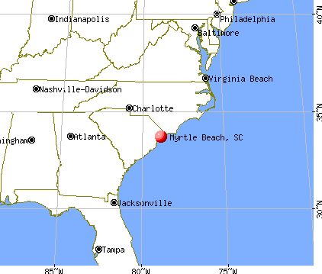
Hilton Head
Kickoff event and sign up is April 2 at the START! Walking Day Festival 2013 @ ODU, 12:30 in Kaufman Mall. Free pedometers to all participants, free T-shirt to the first 25 participants, tracking calendar of events and food!

For more information or questions contact Angie Sutphin, asutphin@odu.edu

For more information or questions contact Angie Sutphin, asutphin@odu.edu

