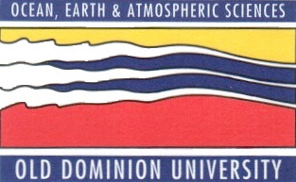

SPRING 2013 SEMINAR SERIES
DEPARTMENT OF OCEAN, EARTH, AND ATMOSPHERIC SCIENCES
3PM – ROOM 200 IN THE OCEANOGRAPHY/PHYSICS BUILDING
THURSDAY MARCH 7th, 2013

“Seasonal Hypoxia in Chesapeake Bay:
Patterns, Trends and Controls”

Dr. Michael Kemp
University of Maryland

ABSTRACT

Although seasonally low oxygen levels are a common feature of most stratified coastal systems, nutrient loading and other human disturbances have expanded and intensified bottom-water oxygen depletion in many of these systems including Chesapeake Bay. This talk will review and integrate recent findings on patterns and trends in seasonal hypoxia and anoxia for Chesapeake Bay and will address questions pertaining to physical and biogeochemical controls.

After the seminar, please join us in room 404, the Zaneveld Conference Room, for coffee and cookies, and to meet with the seminar speaker.

