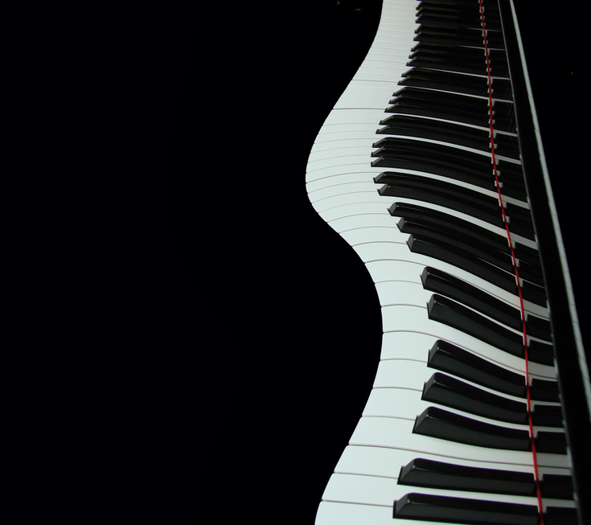
You are cordially invited to attend

The College of Arts & Letters
Fall 2012
Senior Scholar Lecture

John Toomey
Professor of Music

Deciphering Jazz
An Analysis of How Jazz Treats the
Basic Elements
Common to Traditional Music

Thursday, November 1

3:30 Reception, Diehn Atrium

4:00 Lecture, Chandler Recital
Hall, Diehn F&P Arts Bldg.

For more information,
contact the Dean’s Office at 683-3925

