PLEASE JOIN
THE UNIVERSITY WOMEN’S CAUCUS FOR
A CONVERSATION WITH
UNIVERSITY POLICE CHIEF
RHONDA HARRIS

WEDNESDAY, OCTOBER 31ST, 2012
12:00 Noon – 1:00 PM
RIVER ROOMS, WEBB CENTER

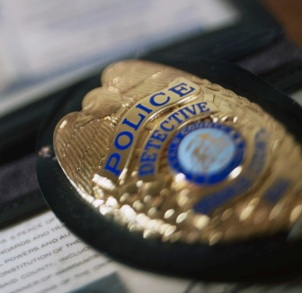

For more information, please contact
Tancy Vandecar-Burdin at tvandeca@odu.edu

